CHEMICAL ENGINEERING TRANSACTIONS  VOL. 91, 2022 | A publication of
The Italian Association
of Chemical Engineering
Online at www.cetjournal.it

Guest Editors: Valerio Cozzani, Bruno Fabiano, Genserik Reniers
Copyright © 2022, AIDIC Servizi S.r.l.
ISBN 978-88-95608-89-1; ISSN 2283-9216

Computer-aided modelling, simulation, and environmental assessment of biodiesel production from microalgae via lipid extraction and transesterification
Ángel Darío González-Delgado*, Aury S. Álvarez-Cordero, Yuranis P. De Ávila-Alvis
Nanomaterials and Computer-Aided Process Engineering Research Group (NIPAC), Chemical Engineering Department, Faculty of Engineering, University of Cartagena, Cartagena 130015, Colombia.
* agonzalezd1@unicartagena.edu.co
Population growth and industrialization have led to an increase in the energy needs of the planet, causing an alarming increase in fossil fuel consumption (coal, oil, and gas), drastically decreasing their availability and contributing to global warming through the accumulation of greenhouse gases. Given the energy and environmental concerns, biofuels have received considerable attention due to their potential to reduce the consumption of fossil fuels. Biodiesel is one of the most attractive biofuels owing to the similar properties to petroleum-derived diesel; it is obtained forward from renewable lipid feedstocks such as vegetable oils and microalgae. The latter has demonstrated to be the best alternative for biodiesel production, mainly due to their high growth rate; therefore, numerous efforts are focused on achieving advances to allow the industrial production of biodiesel. In this work, the modeling, simulation, and environmental evaluation of biodiesel production from microalgae via lipid extraction and transesterification method was carried out. The modeling of the process was performed based on literature data, Aspen Plus commercial software was used for the simulation and the environmental assessment was conducted following the waste reduction algorithm (WAR) that quantifies the output and generated potential environmental impact (PEI), besides allowing the PEI classification under eight different categories. The total PEI output rate was estimated at 1.89E+00 PEI/kg of product suggesting that the process does not emit residues with the potential to negatively impact the environment. Furthermore, the evaluated topology was found to have an environmentally friendly performance in terms of consuming environmental impacts as indicated by the negative value reached for the PEI generated (-1.69E-01 PEI/kg of product). Finally, the category of potential for human toxicity by ingestion reached the highest PEI value, suggesting that the substances involved in the process primarily affect human health.
  - Introduction
Population growth and industrialization have increased the consumption of fossil fuels (coal, oil, and gas) at an alarming rate, resulting in a drastic decrease in their availability in recent decades (Chhandama et al., 2021) and leading to environmental problems such as global warming, since the combustion of fossil fuels causes the accumulation of greenhouse gases (Tang et al., 2020). Due to energy and environmental problems, considerable interest has been shown worldwide in developing sustainable alternative energies (Kumar Pathaka et al., 2017). Biofuels have been found to have the potential to reduce the consumption of fossil fuels (Azadi et al., 2017) ; biodiesel can substitute the fuel used in vehicles since they have properties very similar to petroleum-derived diesel (Ali et al., 2017).
Biodiesel is obtained forward from renewable lipid feedstocks such as vegetable oils and microalgae; the latter has shown to be the preferable alternative mainly due to their high lipid content, fast growth rate, and use of non-cultivable land (Rodolfi et al., 2009). Besides, microalgae can be cultivated in wastewater in such a way that carbon footprint may be reduced (Ahmad et al., 2021). The environmental impact of biodiesel is less than reducing combustion emissions and guarantees the same level of yield as existing fuels. Therefore, numerous efforts are being carried out to advance the commercial viability of microalgae-based biofuels; however, the information and results currently available are insufficient. It requires a large investment in research and development and the right policies and strategies to drive the growth of all stages of the biodiesel production chain, from feedstock production to the final product (Tang et al., 2020). On the other hand, microalgae have been discovered to be a potential candidate for energy production, since they have some advantages over other raw materials and can grow at a rate that is 20 to 30 times faster than other biofuel sources. (Peralta-Ruiz et. al., 2018).
In this work, biodiesel production from microalgae via lipid extraction and transesterification is designed and simulated, and the environmental performance is evaluated through the waste reduction algorithm (WAR). The WAR algorithm allows the quantification of the potential environmental impacts emitted and generated and gives an idea of the internal and external environmental efficiency of the process. The objective of this work is to determine the environmental performance of the process to improve the necessary stages or points to implement it on an industrial scale.
  - Materials and Methods
    - Process modeling
The block diagram for microalgae-based biodiesel production via lipid extraction and transesterification is presented in Figure 1. Microalgae are fed at environment temperature to the culture stage along with a nutrient stream and are subsequently subjected to a harvesting process. The harvested microalgae are sent to a drying stage where moisture content is reduced to 5% (Bauer et al., 2017). The dried microalgae stream passes to the next stage where lipid extraction occurs at 40°C and 1.01 bars with the addition of hexane as solvent at a molar ratio of lipid: hexane 1:20 (Peralta-Ruiz et al., 2013). This solvent is selected since it is highly efficient in degrading the cell wall of the microalgae, allowing an effective extraction of the oils (Mercer & Armenta, 2011). In this stage, the microalgae cake (carbohydrates, proteins) is discarded, while another stream which is rich in fatty acids, triglycerides, and hexane (microalgae liquor) is sent to the hexane recovery unit. About 97% of the hexane is separated in a distillation process (Mohadesi et al., 2020) and fed back to the lipid extraction stage. Next, the mainstream is sent to the transesterification stage where the reaction of the fatty acids and triglycerides with methanol takes place through the addition of sulfuric acid as a catalyst. Methanol and catalyst are added to the process in molar ratio methanol: lipid 12:1 and catalyst: lipid 1:1 (Musa, 2016).
Figure 1. Block diagram of microalgae-based biodiesel production via lipid extraction and transesterification
    - Environmental assessment
The environmental analysis of microalgae-based biodiesel production via lipid extraction and transesterification was carried out using the Waste Reduction Algorithm (WAR) developed by the National Risk Management Research Laboratory of the U.S. Environmental Protection Agency (EPA) (Meramo et al., 2018). The WAR algorithm introduces the concept of Potential Environmental Impact (PEI) and is based on a PEI balance, which is analogous to a mass or energy balance. The balance involves the flow of an environmental impact across system boundaries, which may be due to mass or energy crossing those boundaries.
The impacts emitted by the process (output impacts) measure the efficiency of the process in obtaining final products at a minimum potential environmental discharge impact. Equations 1 and 2 show the expressions for calculating the output rate of PEI per unit of time (hour) and per unit of mass (kg of product), respectively. The generation of environmental impacts (impacts generated) measures the amount of environmental impact consumed or generated by the process. The PEI generated are calculated as shown in Equations 3 and 4 per unit of time (hour) and per unit of mass (kg of product), respectively.
$${\hat{\dot{i}}}_{out}^{(t)}={\dot{i}}_{out}^{(cp)}+{\dot{i}}_{out}^{\left(ep\right)}+{\dot{i}}_{we}^{\left(cp\right)}+{\dot{i}}_{we}^{(ep)}$$ | (1)
$${\hat{\dot{i}}}_{out}^{(t)}=\frac{{\dot{i}}_{out}^{(cp)}+{\dot{i}}_{out}^{\left(ep\right)}+{\dot{i}}_{we}^{\left(cp\right)}+{\dot{i}}_{we}^{(ep)}}{\sum_{p}{P_{p}}}$$ | (2)
$${\hat{\dot{i}}}_{gen}^{(t)}={\dot{i}}_{out}^{(cp)}-{\dot{i}}_{in}^{\left(cp\right)}+{\dot{i}}_{out}^{\left(ep\right)}-{\dot{i}}_{in}^{\left(ep\right)}+{\dot{i}}_{we}^{\left(cp\right)}+ {\dot{i}}_{we}^{(ep)}$$ | (3)
$${\hat{\dot{i}}}_{gen}^{(t)}=\frac{{\dot{i}}_{out}^{(cp)}-{\dot{i}}_{in}^{\left(cp\right)}+{\dot{i}}_{out}^{\left(ep\right)}-{\dot{i}}_{in}^{\left(ep\right)}+{\dot{i}}_{we}^{\left(cp\right)}+ {\dot{i}}_{we}^{(ep)}}{\sum_{p}{P_{p}}}$$ | (4)
Also, it allows the evaluation of the potential for environmental impact in eight impact categories: Human toxicity potential by ingestion (HTPI), human toxicity potential by inhalation or dermal exposure (HTPE), aquatic toxicity potential (ATP), terrestrial toxicity potential (TTP), ozone depletion potential (ODP), global warming potential (GWP), photochemical oxidation potential (PCOP) and acidification potential (AP). The first four categories are classified as toxicological and the others as atmospheric.
  - Results and Discussion
The simulation for microalgae-based biodiesel production via lipid extraction and transesterification is developed taking into account the following considerations:
- The simulation of the process was carried out in a steady state.
- The NRTL (Non-Random Two Liquid) thermodynamic model was selected considering the highly polar nature of water, hexane, methanol, and glycerol and the presence of electrolytes such as sulfuric acid.
- Production capacity of 1,000 kg/h of microalgae.
- The transesterification reaction was simulated with a conversion of 90% (Ehimen Ehiaze, 2010).
- The neutralization reaction was simulated with a 99% conversion (Ehimen Ehiaze, 2010).
Figure 2 shows the simulation of microalgae-based biodiesel production via lipid extraction and transesterification. The microalgae (stream MICROALG) are fed together with 9,000 kg/h of nutrients (stream NUTRIENT) to the tank TK-01 where the culture process takes place, then the microalgae are harvested in a centrifuge (D-01) in which water is removed. The remaining moisture of the microalgae is removed in the dryer M-01 where a stream of air at 50°C (stream DRYAIR) enters. The microalgae with a moisture content of approximately 5% (stream 6) are sent to reactor B3 where lipid extraction occurs using hexane as a solvent (stream 8). The mainstream (stream 9) is sent to separator B7 where the solid part or microalgae cake (stream 10) is separated from the microalgae liquor (stream 12).

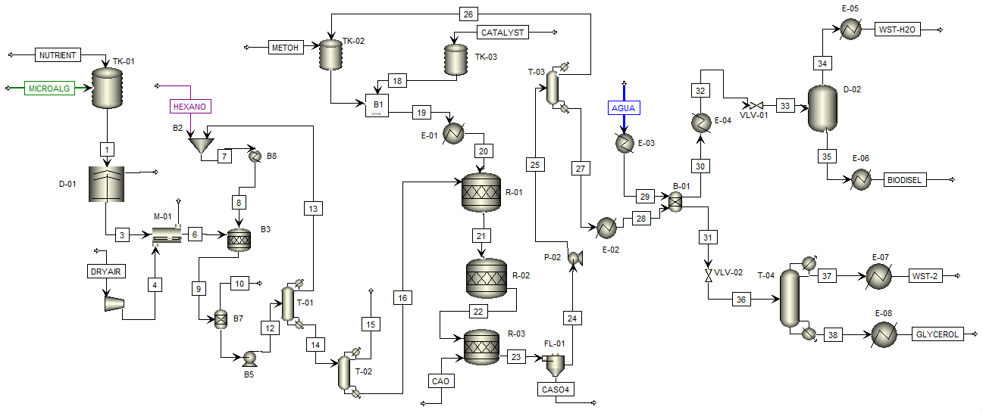
Figure 2. Simulation of microalgae-based biodiesel production via lipid extraction and transesterification
Stream 12 enters the distillation column T-01 where approximately 97% of the hexane is recovered for recirculation to the lipid extraction reactor. The stream rich in fatty acids and triglycerides (stream 16) is sent to the transesterification reactor R-01 where methanol and sulfuric acid (catalyst) are added. The catalyst was selected, taking into account that the fatty acid content is higher than 1%; therefore, acid catalysis is much more effective than base catalysis (Ehimen Ehiaze, 2010; Ghadge & Raheman, 2005; Veljkovic et al., 2006). The stream coming out of the reactor (stream 22) is rich in biodiesel and glycerol and passes to the neutralization reactor R-03 where the catalyst is neutralized with CaO. The neutralized stream (stream 24) goes to the distillation column T-03; approximately 87% of the methanol is recovered and recirculated to the transesterification stage (stream 26). The stream rich in biodiesel and glycerol (with small traces of triglycerides, fatty acids, hexane, CaO, methanol, catalyst) is subjected to washing in the equipment B-01. In this equipment, a water stream is fed at 70°C which removes the glycerol to separate it from the biodiesel. The hydrophobic stream (stream 30) rich in biodiesel and small traces of water is sent to the flash separator D-02 for biodiesel purification. The hydrophilic stream (stream 31) is sent to a process of distillation in tower T-04 to purify the glycerol. Finally, biodiesel and glycerol are obtained at a rate of 208 kg/h and 97.27 kg/h, respectively. The environmental analysis for the microalgae-based biodiesel production via lipid extraction and transesterification was carried out using Wargui software, taking into account the following considerations:
- The fuel used as an energy source was natural gas due to being the least polluting concerning coal - and oil (Alvarez et al., 2017).
- The energy required in the processes was estimated at 20,794.72 MJ/h.
Figure 3 shows the environmental performance of microalgae-based biodiesel production via lipid extraction and transesterification. Total PEI generation reaches negative values (-51.60 PEI/h or -0.17 PEI/kg of product) suggesting that high-value products (biodiesel and glycerol) generate less impact on the environment than raw materials (microalgae, hexane, methanol, sulfuric acid). These findings justify the production of microalgae-based biodiesel and indicate that the process has an environmentally friendly performance. On the other hand, the total PEI rate was estimated at 1.89 PEI/kg of product for the annual production of 2006.56 tons of biodiesel and 939.55 tons of glycerol; this value, which is close to 1, confirms the good environmental performance of the modeled and simulated process.
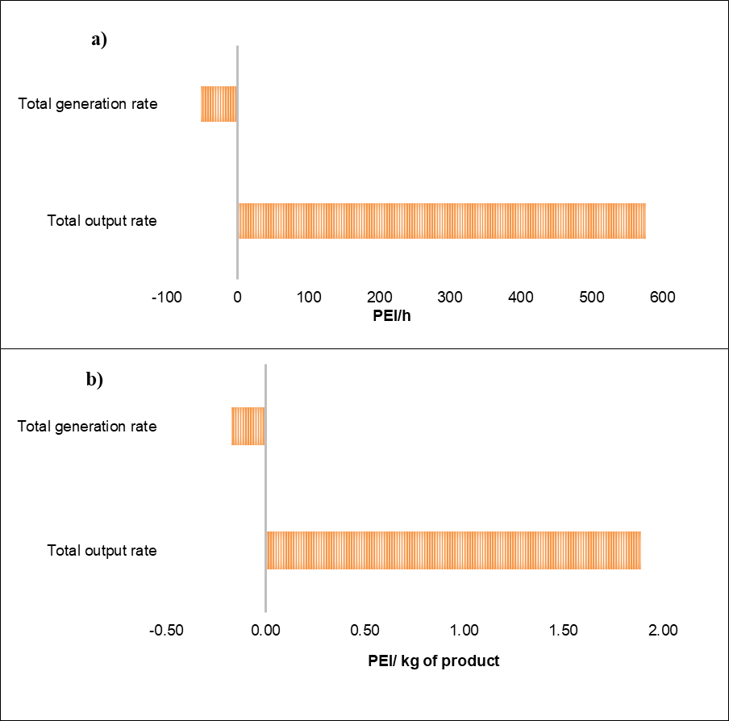
Figure 3. Total environmental performance of microalgae-based biodiesel production via lipid extraction and transesterification a) PEI per unit of time, b) PEI per unit of mass
The results obtained for the toxicological impacts emitted and generated are presented in Figure 4. The HTPI and TTP categories reach the highest estimates of PEI production contributing 68.40% to the total PEI emission rate. These results relate to the discharge of substances such as sulfuric acid, calcium sulfate, and hexane, which tend to be highly toxic, especially hexane, whose exposure generates polyneuropathy and dangerous effects on female reproduction (Liu et al., 2012). In terms of human toxicity potential from exposure (HTPE), a value of 26.70 PEI/h was obtained corresponding to output impacts category. For all toxicological categories, negative values were calculated for the impacts generated, indicating that the final products are less toxic compared to raw materials.
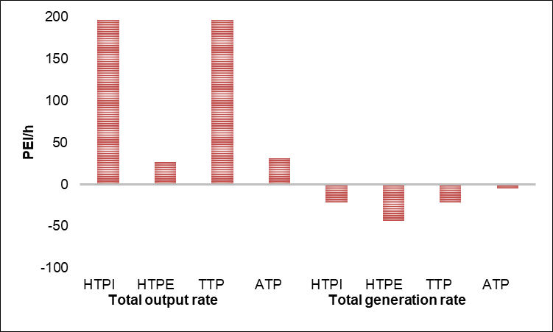
Figure 4. Toxicological impacts from microalgae-based biodiesel production via lipid extraction and transesterification
Figure 5 shows that photochemical oxidation potential (PCOP) category reaches the highest value for atmospheric output impacts (102 PEI/h) resulting from the output of biodiesel, which is a substance that tends to favor the formation of smog. The output impacts of the acidification potential (AP) were estimated at 20.60 PEI/. This is due to the presence of sulfuric acid used as a catalyst in the transesterification stage. For global warming potential (GWP) and ozone depletion potential (ODP), no output impacts were reported, indicating that the process is neutral under these categories. On the other hand, the generation of impacts was positive for the atmospheric categories, showing that the products have a higher potential for atmospheric impact than the raw materials, mainly because biodiesel contributes to the formation of smog.
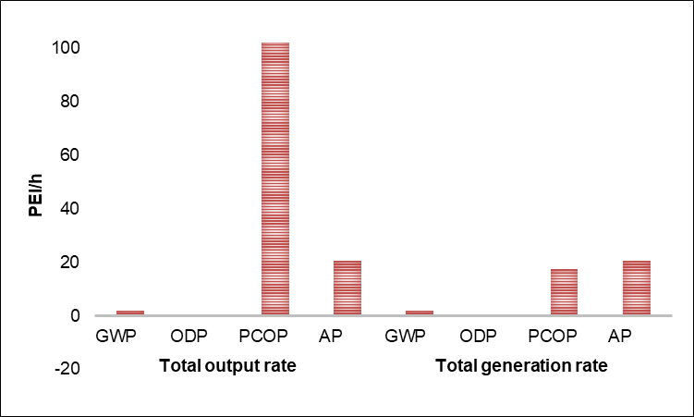
Figure 5. Atmospheric impacts of microalgae-based biodiesel production via lipid extraction and transesterification
  - Conclusions
In this study, the modeling, simulation, and environmental evaluation of microalgae-based biodiesel production via lipid extraction and transesterification was performed. The topology was simulated using Aspen Plus software for a processing capacity of 1000 g/h of microalgae. The total PEI output rate was estimated at 1.89E+00 PEI/kg of product suggesting that the process does not emit residues with the potential to negatively impact the environment. Furthermore, the evaluated topology was found to have an environmentally friendly performance in terms of consuming environmental impacts as indicated by the negative value reached for the PEI generated (-1.69E-01 PEI/kg of product). On the other hand, biodiesel production from microalgae via lipid extraction and transesterification was found to have lower generated environmental impacts (-51.6 PEI/h) compared to a Palm-based biorefinery (-0.153 PEI/h) (Herrera-Aristizabal et. al., 2017). Finally, the total output rate of potential for human toxicity by ingestion (HTPI) reached the highest value; this means the substances, which leave the process, may affect human health.
Acknowledgments
The authors want to thank the Universidad de Cartagena for providing the equipment and software to successfully conclude this research.
References
Ahmad I., Abdullah N., Koji I., Yuzir A., 2021, The Contribution of Microalgae in Bio-refinery and Resource Recovery: A Sustainable Approach leading to Circular Bioeconomy, Chemical Engineering Transactions, 89, 391-396.
Ali M., Sultana R., Tahir S., Watson I. A., Saleem M., 2017, Prospects of microalgal biodiesel production in Pakistan – A review, Renewable and Sustainable Energy Reviews, 80, 1588–1596.
Álvarez A., De Ávila Y., González-Delgado A. D., Ortiz M., 2017, Environmental Assessment of Dual Crude Palm and Kernel Oil Production in North-Colombia using WAR Algorithm, Journal of Engineering and Applied Sciences, 12, 7265–7271.
Azadi P., Malina R., Barrett S. R. H., Kraft M., 2017, The evolution of the biofuel science, Renewable and Sustainable Energy Reviews, 76, 1479–1484.
Bauer L.M., Costa J.A., Da Rosa A.P.C., Santos L.O., 2017, Growth stimulation and synthesis of lipids, pigments, and antioxidants with magnetic fields in Chlorella kessleri cultivations, Bioresource Technology, 244, 1425–1432.
Chhandama M. V. L., Satyan K. B., Changmai B., Vanlalveni C., Rokhum S. L., 2021, Microalgae as a feedstock for the production of biodiesel: A review, Bioresource Technology Reports, 15, 100771.
Ehimen A., 2010, An investigation on the co-production of biodiesel and methane from microalgae, PhD Thesis, University of Otago, Dunedin, NZ.
Ghadge S. V., Raheman, H., 2005, Biodiesel production from mahua (Madhuca indica) oil having high free fatty acids, Biomass and Bioenergy, 28, 601–605.
Herrera-Aristizábal R., Salgado-Dueñas J., Peralta-Ruiz Y., Gonzalez-Delgado A., 2017, Environmental evaluation of a palm-based biorefinery under north-colombian conditions, Chemical Engineering Transactions, 57, 193-198.
Kumar P P., Rajb J., Saxenab G., Shankar U., 2017, A Review on Production of Biodiesel by Transesterification using Heterogeneous Nanocatalyst, International Journal of Scientific Research & Development, 5, 631-636.
Liu J., Huang H. L., Pang F., Zhang W. C., 2012, The Effect of n-Hexane on the Gonad Toxicity of Female Mice, Biomedical and Environmental Sciences, 25, 189–196.
Meramo S., Ojeda-Delgado K., Sanchez, E., 2018, Environmental Assessment of a Biorefinery: Case Study of a Purification Stage in Biomass Gasification, Contemporary Engineering Sciences, 11, 113–120.
Mercer P., Armenta R. E., 2011, Developments in oil extraction from microalgae, European Journal of Lipid Science and Technology, 113, 539–547.
Mohadesi M., Aghel B., Maleki M., Ansari A., 2020. Study of the transesterification of waste cooking oil for the production of biodiesel in a microreactor pilot: The effect of acetone as the co-solvent, Fuel, 273, 17736
Musa I. A., 2016. The effects of alcohol to oil molar ratios and the type of alcohol on biodiesel production using transesterification process, Egyptian Journal of Petroleum, 25, 21–31.
Peralta-Ruiz Y., González-Delgado A. D., Kafarov V., 2013, Evaluation of alternatives for microalgae oil extraction based on exergy analysis, Applied Energy, 101, 226–236.
Peralta-Ruiz Y., Obregon L, Gonzalez-Delgado A., 2018, Design of biodiesel and bioethanol production process from microalgae biomass using exergy analysis methodology, Chemical Engineering Transactions, 70, 1045-1050.
Rodolfi L., Zittelli G. C., Bassi N., Padovani G., Biondi N., Bonini G., Tredici M. R., 2009. Microalgae for oil: strain selection, induction of lipid synthesis and outdoor mass cultivation in a low-cost photobioreactor, Biotechnology and Bioengineering, 102, 100–112.
Tang D. Y. Y., Yew G. Y., Koyande A. K., Chew K. W., Vo D. V. N., Show P. L, 2020, Green technology for the industrial production of biofuels and bioproducts from microalgae: a review, In Environmental Chemistry Letters, 18, 1967–1985.
Veljkovic V. B., Lakicevic S. H., Stamenkovic O. S., Todorovic Z. B., Lazic, M. L., 2006, Biodiesel production from tobacco (Nicotiana tabacum L) seed oil with a high content of free fatty acids, Fuel, 85, 2671–2675.

